After downloading zip file to your W2G2011 folder, unzip the file as shown below.
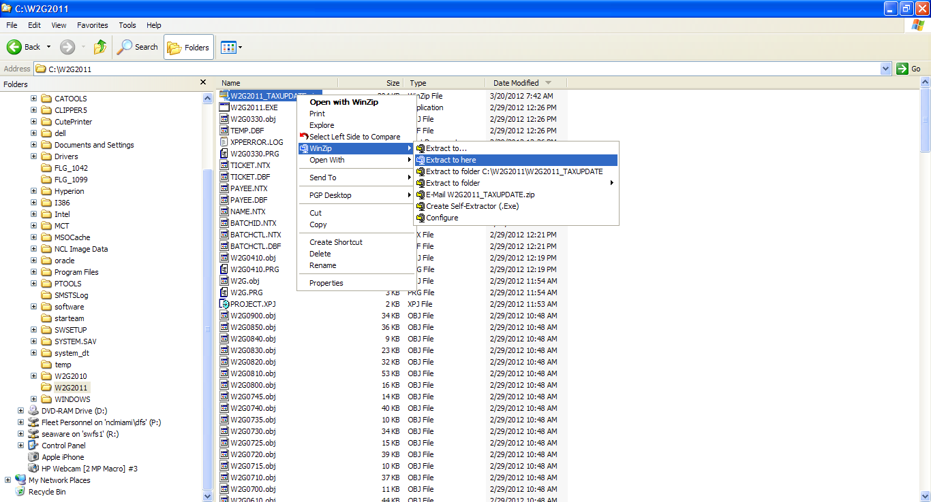
Next, check to confirm the update was installed correctly. Start a command window as shown below.
Click on the Start button, then click on Run.
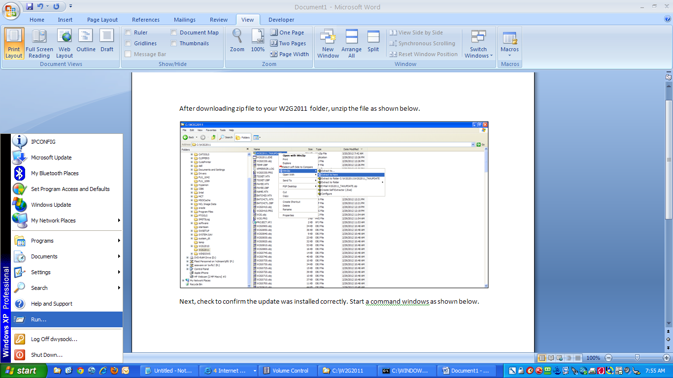
Click here
Then here
At the dialog box enter the letters “cmd” (no quotes), then click the Ok button.
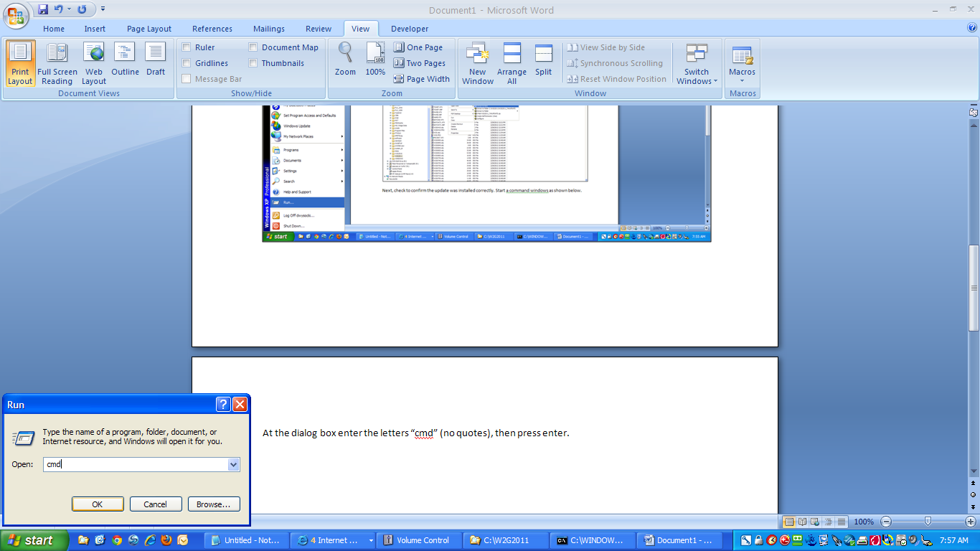
A command window will open as shown below.
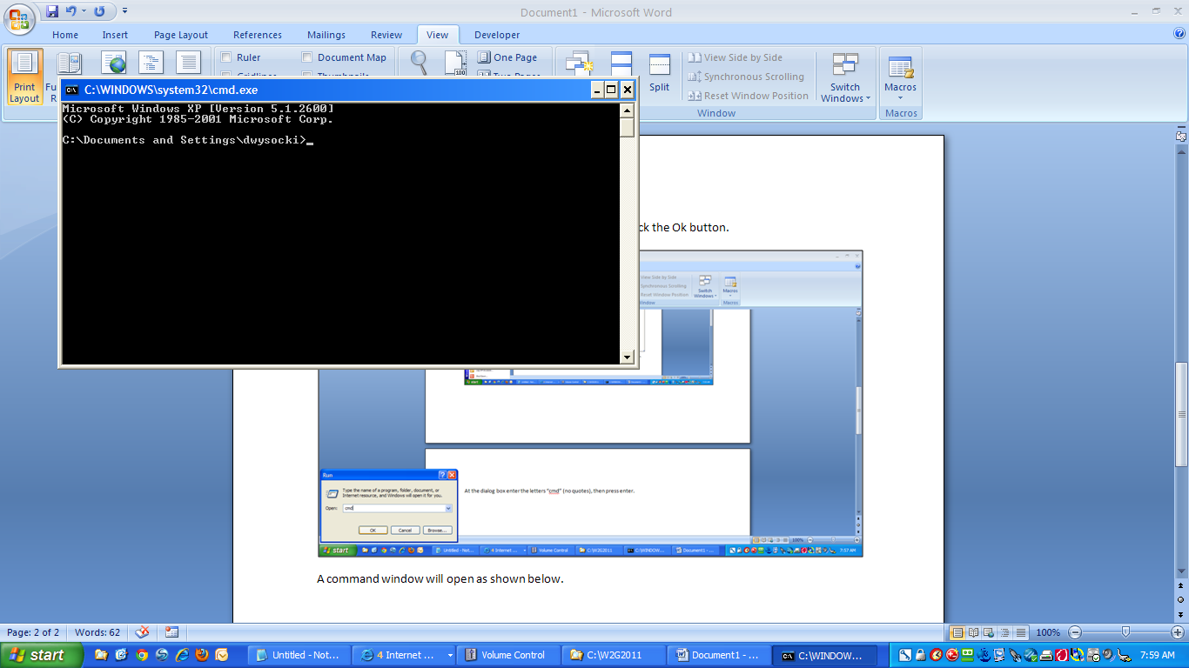

Enter the following command and press enter:
CD \W2G2011<Enter>
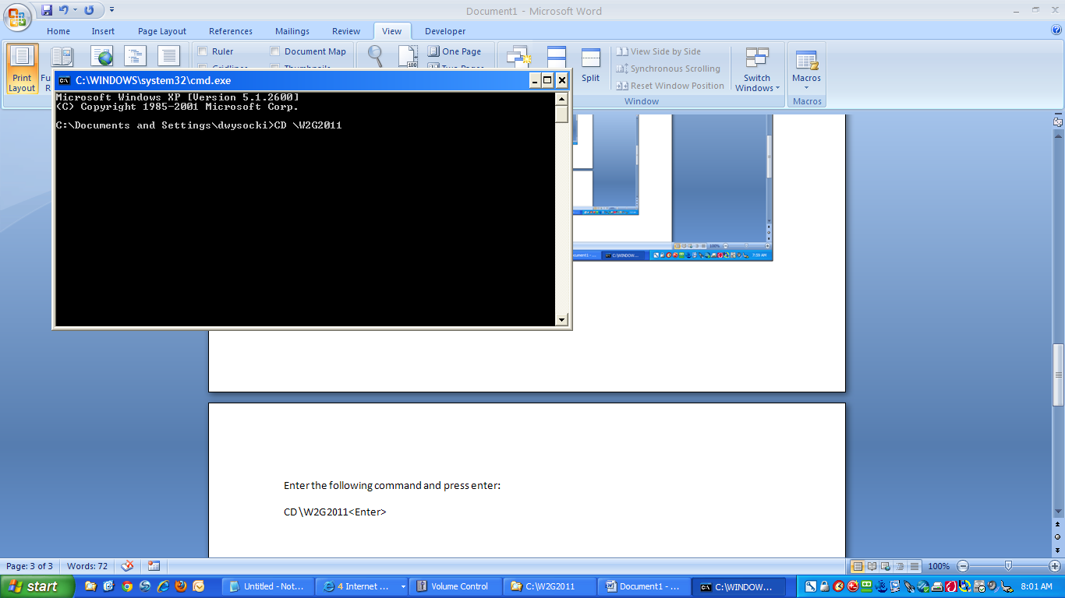
The command window should appear as follows: (Note, your drive letter may be a network drive instead of the C: drive)
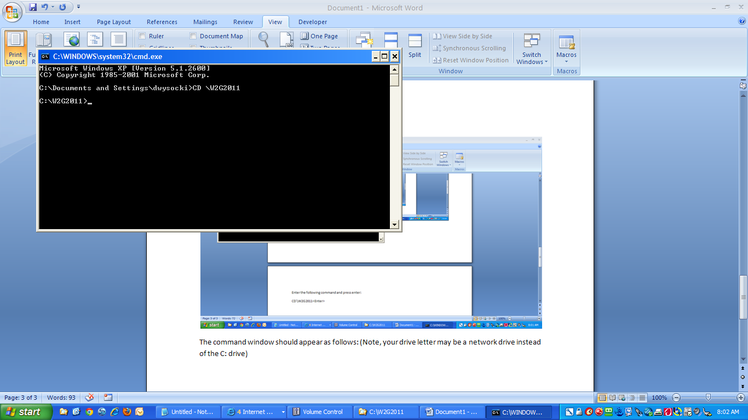
Enter the following command and press enter
C:\W2G2011\dir w2g.exe<Enter>
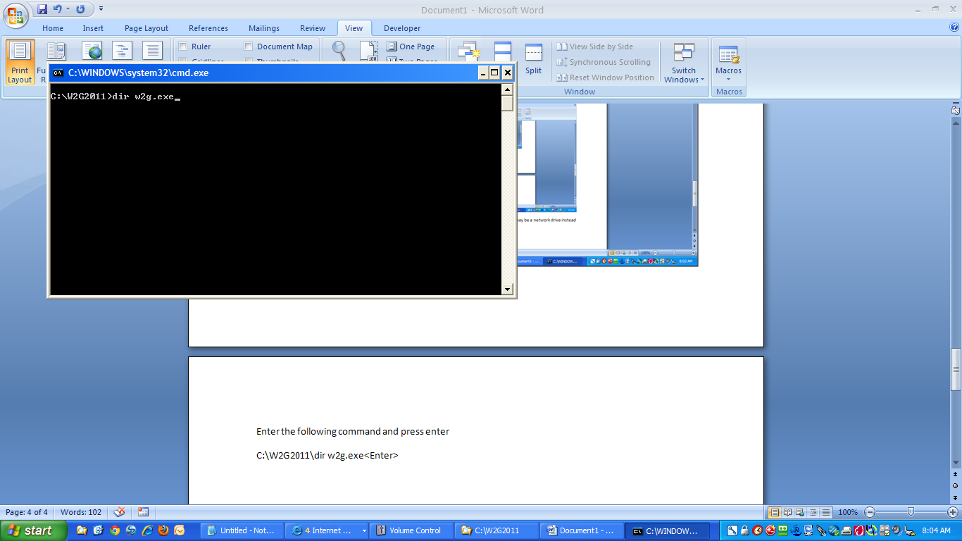
You should see the file has a date and time stamp of March 20th, 2012. 7:41 am.
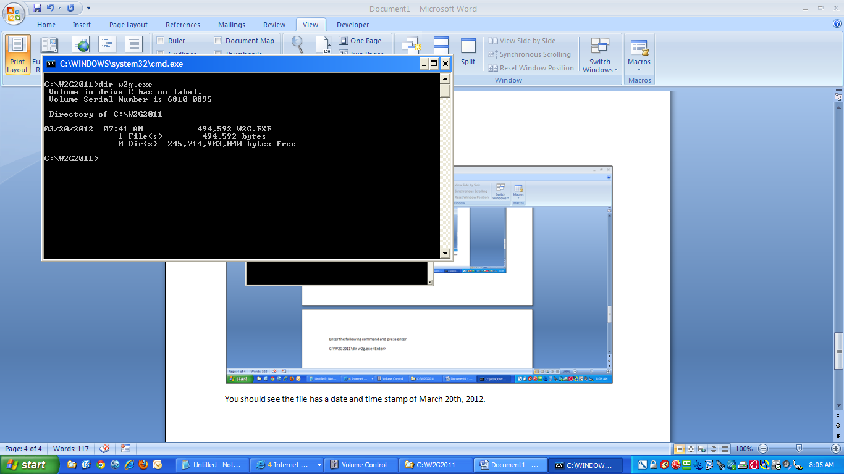

When you run the magnetic media program, please be sure it shows the 2011 Magnetic Media as shown below.
Confirm 2011 Version
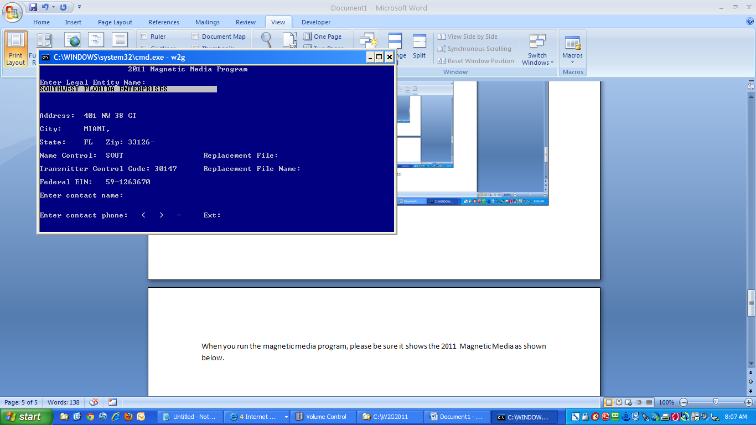
The deadline is March 31st, 2012. Flagler has uploaded without any problem. Please try to complete as soon as possible so that we can address any issues that may occur.
The remainder of the process is the same as previous years.

